
New road layout to be trialled in St Ives
3 November 2025

Road users are being urged to slow down, look around and approach with caution as changes to the current road layout on Tregenna Hill in the centre of St Ives are trialled from November.

From Monday, 17 November only buses, cyclists and emergency services (including lifeboat crews on active duty) will be permitted to drive northbound down Tregenna Hill from The Terrace. All traffic will still be able to drive southbound up Tregenna Hill.

You can watch a short video about the trial here

The general removal of northbound traffic down Tregenna Hill will reduce the current delays, impact and congestion created by vehicles having to navigate past each other in a highly constrained space. The changes will also make it easier for buses, lorries and other large vehicles to get around the narrow points and corners along the route.

There are currently numerous daily conflicts between vehicles and pedestrians using this stretch of road. Previous community consultations have identified this area as one of the main highway concerns for the local community, but it is also one of the more complex environments to implement an effective solution.

Following significant appraisal, technical assessment and broad engagement, a new road layout has now been designed.

The aim of the trial, which will be implemented via an ‘Experimental Traffic Regulation Order’ (ETRO), is to improve traffic flow and reduce these daily conflicts.

While the trial alone is unlikely to reduce the overall amount of traffic at Library Corner, ensuring that general traffic will only be flowing in one direction will significantly reduce the opportunity for conflicts to occur. This will create a more controlled environment and provide a safer space for all users in and around Library Corner.

The changes will also support the broader aims of the Town Deal Transport Strategy and the creation of a Low Traffic Environment in the town centre.

New signs will be installed at key roads and junctions informing drivers of the changes and new restrictions and providing details of alternative routes into and out of St Ives. During at least the first week of the trial, traffic marshals will also be in place at key locations to help support drivers who may be unaware or unsure of the change.

Other measures being introduced as part of this trial include making Albert Road one-way inbound, improving the flow of traffic and reducing traffic congestion and delays, introducing an entry restriction on the western end of Dove Street and a mandatory left turn at Street-an-pol. There will also be no right turn at the bottom of Bedford Road.

The direction of the existing one-way at Park Avenue will also be reversed, allowing inbound traffic only towards Bullans Lane and the Doctors surgery. This will help to keep traffic moving along this route, reducing the numbers of queuing stationary vehicles.

This change is intended to deliver several specific benefits for residents of Park Avenue including:
- Potential reduction in the number of vehicles using Park Avenue
- Reduction or removal of the local buses, a long-standing aspiration of residents
- Create opportunity to consider further restriction of larger vehicles by decreasing the current weight restriction

The change to the traffic flow along Park Avenue will also help to reduce a potential network pressure up over the Burrows to the Stennack, past Trenwith Car Park and Leisure Centre, as a consequence of the proposed trial changes.

By providing a route for local traffic, the reversal will help maintain a balance of vehicles on the road network in this part of the town. This will be closely monitored throughout the trial.

The use of an ETRO means that Cornwall Council as Highways Authority can make modifications throughout the trial period, responding agilely to specific issues or concerns that are observed.

This will provide a greater chance for success, with both community feedback and engineer analysis shaping the ultimate decision making as to whether the trialled changes are made permanent or not.

“We expect the changes to go a long way to addressing the core safety related issues on Tregenna Hill and Library Corner. However, given the complexity of the road network in St Ives, it is difficult to determine exactly how such changes will perform overall “ said Project Lead Kieren Couch. “The trial means we can monitor the effectiveness and realise both benefits and impacts before making any decision on whether to implement a permanent scheme. “

“The community can support us by providing their feedback, both positive and negative, allowing us to respond proactively and make informed decisions.”

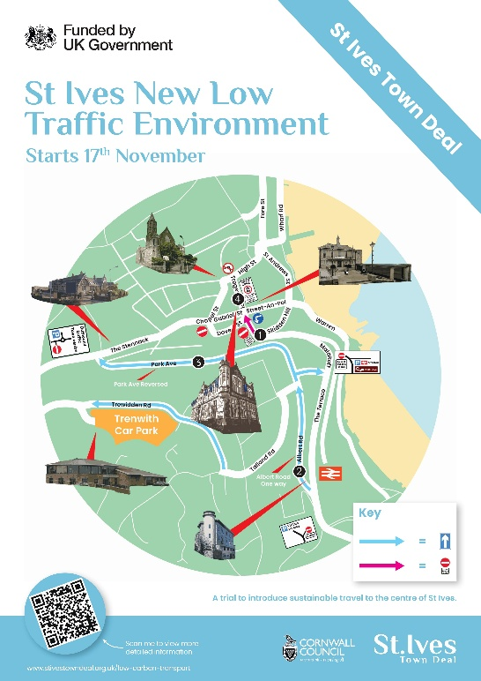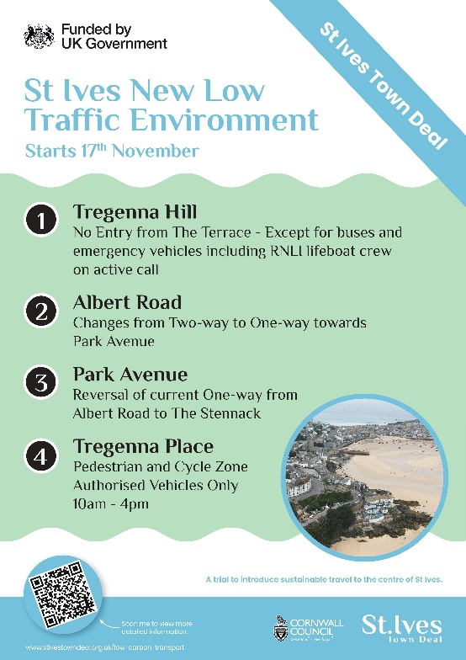

The ETRO has been developed by Cornwall Council in partnership with St Ives Town Deal Board, with technical expertise provided by Cormac. Engagement with key stakeholders, including St Ives Town Council, transport operators and providers and emergency services, has influenced the development of the new road layout which is now being trialled.

“The Town Deal Board is pleased to help fund this ETRO in St Ives “ said Chair Andrew Baragwanath. “As a local person, I know there is no perfect solution to the needs of all road users in and around St Ives but this is an opportunity to see if we can improve the situation, whilst also improving the environment in our town."

Cllr Dan Rogerson, Cornwall Council cabinet member for transport, said “Funding from the Town Deal has always been about supporting communities to develop their plans for their local area. Tregenna Hill is a narrow road lined with narrow footways and shops either side, which means there are limited engineering options for improving safety and traffic flows. Being able to limit traffic under this experiment means we can trial these initiatives and assess the impact before making any permanent changes.”

Councillor Johnnie Wells, Mayor of St Ives and Chair of the Low Carbon Transport Working Group added “ This is going to be a big change and we understand there will be reservations, but the current traffic situation, especially around Tregenna Hill and Library corner just can’t carry on.

“We ask that everyone is patient, and gives it some time to bed in… but I believe this will be transformational for St Ives, and make driving through town easier, as well as reducing traffic and freeing up road space in order to make walking a cycling safer.”

The trial is being funded through the St Ives Low Carbon Transport Strategy and will remain in place for at least six months but could extend up to 18 months before a final decision is made.

The project team will be engaging with people living and working in the town, the wider local community and businesses, and key stakeholders, including emergency services, transport operators and providers, over the next few weeks ahead of the start of the trial.

A specific Tregenna Hill ETRO webpage is being set up on Let’s Talk Cornwall to provide information about the trial and enable people to raise feedback throughout the trial period. This will go live at the launch of the trial. We will remain open and transparent, regularly posting updates throughout.

The project team will be encouraging feedback from all sectors of the local community, as well as visitors to the town, during the trial to enable the performance of the scheme to be fully determined. This feedback, along with active monitoring by transport engineers, will be used to shape the decision on a permanent scheme.

The St Ives Low Carbon Transport Strategy received £3 million from the government’s Town Deal programme and £2.5 million match funding from Cornwall Council.

Ends

Notes to editors
About the UK Government Town Deals programme
The Town Deals programme aims to regenerate towns and deliver long-term economic and productivity growth. This is through investments in urban regeneration, digital and physical connectivity, skills, heritage and enterprise infrastructure. As of July 2021, DLUHC (now MHCLG) had offered Town Deals to all 101 places that submitted proposals, committing over £2.35bn of investment across c.700 projects nationwide. See the press releases associated with Town Deals on gov.uk.
Cornwall is the only area invited by the Government to submit proposals for four of its towns: Camborne, Penzance, St Ives and Truro. After conducting extensive public consultations, each Town Deal Board submitted their Town Investment Plan in collaboration with Cornwall Council. As a result, the Government announced in spring 2021, that Cornwall will receive up to £88.7 million from the Town Deals programme.
For more information visit: www.cornwall.gov.uk/business-trading-and-licences/economic-development/towns-fund

About St Ives Town Deal
In June 2021, St Ives secured a Town Deal of up to £19.9 million following the successful submission of its Town Investment Plan for a range of regeneration projects. For more information about St Ives Town Deal visit www.stivestowndeal.org.uk
Cornwall Council is the Lead Authority for the Town Deals in Cornwall. Cornwall Council supports the governance role of St Ives Town Deal Board and is responsible for administering the Fund on behalf of the Board.
One of the nine Town Deal projects being funded and delivered as part of the St Ives Town Deal programme, the aim of the Low Carbon Transport Strategy is to help reduce the impact of vehicles on St Ives and introduce measures that encourage walking, cycling and the use of public transport.
The Strategy, which has been allocated £5.5 million of Town Deal and Cornwall Council funding, includes proposals aimed at reducing traffic congestion and parking demand in the town centre, enhancing public transport options and accessibility, improving air quality and health outcomes for residents and visitors, and supporting local businesses by creating a more attractive and vibrant town.

About the ETRO process
The use of an Experimental Traffic Regulation Order means there is no formal pre consultation process carried out before a scheme is put in place. Instead all comments made during the trial are treated as part of a “live consultation” and are taken in account before any decision is made on a permanent scheme.
While the experimental order is a legal document which is enforceable by the police, unlike permanent traffic regulation orders it also allows any parts of the scheme which are not working as expected operationally or for other reasons to be modified without having to wait for the end of the experiment.
The ETRO process enables measures to remain in place for up to 18 months, with the scheme reviewed at the end of 6 months.

